Content Management Portal (CMP) Project
Project Plan

Filing Reference: |  | CMP/DOCS/MP.1/
Document Title: |  | Project Plan
Version: |  | 2.0
Prepared/Revised by: |  | Sui Haiyang
Date: |  | 30 March 2009
Approved by: |  | Sui Haiyang (Project Manager)
Approved Date: |  | 30 March 2009
 | © 2009  The information contained in this document is the property of ISS. The contents must not be copied in whole or in part for purposes other than which it has been supplied without the consent of ISS, or, if it has been furnished under contract to another party, as expressly authorised under that contract, then ISS shall not be liable for any errors or omissions. |  | 
Institute of Systems Science, 25 Heng Mui Keng Terrace,
Singapore 119615

Version History Record
Version | Date | Brief description of amendments and affected pages, paragraph
0.1 | 18/03/09 | Submitted for customer’s review

Distribution:

Name | Department | Organisation
ISS Audit | ISS | ISS
Sui Haiyang | Project Manager | ISS-SE16S07
Gao Jia Si Karen | Quality Manager | ISS-SE16S07
Yap Sie Kuok, Thomas | Testing Manager | ISS-SE16S07
May Ann Sallan | Database Designer | ISS-SE16S07
Rajendran Kumaraguru | System Architect | ISS-SE16S07
Thiyagarajan Ravikumar | Technical Lead | ISS-SE16S07

Table of Contents
1. INTRODUCTION 1
1.1 Purpose 1
1.2 Audience 1
1.3 Organization 1
1.4 References 1
2. Approach 2
2.1 Project Initiation 2
2.2 Requirement Analysis 2
2.3 Prototype Development 2
2.4 System Analysis and Design 3
2.5 Software Development 3
2.6 System Integration Test 3
2.7 User Acceptance Test 3
3. Work plan 4
3.1 User Requirement Analysis 4
3.2 Prototype Development 5
3.3 System Analysis 5
3.4 System Design 6
3.5 Software Development 6
3.6 System Integration Test 7
3.7 User Acceptance Test 7
3.8 User Sign-off 8
3.9 Management and Administration 8
3.10 Management and Administration 9
4. Staff effort estimate 10
5. timescale and milestones 11
6. Deliverables 18
7. Deliverables 19
8. Project structure and staffing 20
9. Project structure and staffing 23
9.1 Accommodation 23
9.2 Computer Hardware and Software 23
9.3 Word Processing 23

INTRODUCTION
The Index Info Systems Pte Ltd (IIS) requires the development and deployment of a web learning portal for their business strategy partners and customers to fulfil their staff learning and training requirements. Through this system, IIS can create unlimited and diverse learning packages, including the learning content, MCQ (Multiple Choice Question), Survey, Certificate, User Control etc. IIS can then sell the packages to their business customers, and support them with their staff learning process.

Purpose
The purpose of this document is to provide a Project Plan for the work to complete this project to develop the Content Management Portal.

Audience
The intended readers of this Project Plan are the project team, by reading this document; they should be able to understand:
- The activities that each member needs to perform;
- The deliverables to be produced in each stage, and who is responsible for creating those deliverables.
The timeline and the effort they need to contribute to the project

Organization
The approach to be adopted by the project to carry out the work is summarized in Section 2 and major activities are identified in Section 3. Staff effort estimates to undertake the work are defined in Section 4 and timescales are given in Section 5. Section 6 describes the deliverables and Section 7 gives details of the project's structure and staffing. Finally, the resources required to support the work are specified in Section 8.

References
In order to fully understand the background of this project, the readers should read through and understand the User Requirement Specifications (URS) and Quality Plan.

Approach
The approach followed by the team to develop this project is specified as follows:

Project Initiation
To initialize this project, a formal Project Plan will be created, followed by a Quality Plan. A Project Filing System will also be established to facilitate the document version control and group discussion.

Requirement Analysis
The project will perform the activity of Requirement Analysis with following approaches:
- Project kick-off meeting with customer representative
- Initial requirement gathering by meeting customer
- Internal discussion on requirement analysis
- Document user requirements

Prototype Development
Based on user requirements gathered, the prototype will be developed. The prototype will be developed with C#.NET, IIS, and AJAX. Some main features of the system will be converted to prototype, and a web site will be established. Every pages of the prototype will be reviewed and commented by customer, and according to customer feedback, a final prototype will be created and ready for future development. In the process of creating and analyzing the prototype, user requirements will be further clarified and documented in system specification document.
Besides, the customer may raise new ideas when viewing prototypes. These new requirements will be analyzed and added into user requirement specifications when necessary. The addition or removal of user requirements will be well documented in the change management control documents.

System Analysis and Design
During the analysis stage use case will be identified and use case realisation reports will be produced. During the design stage all the use cases will be realised further on and respective use case realization report, class diagrams, sequence diagram will be produced. The system architecture will be designed.

Software Development
During the development of the system user guide will be prepared for the user.

System Integration Test
System Integration Test contributes an important part in software implementation. A well written Test Plan will assure the system to be tested properly in a systematic way, the analysis on test results and the revision actions taken will be documented.

User Acceptance Test
After the system integration testing and unit testing of the system, the system will be deployed for User Acceptance Test (UAT). The end to end functionality of the system will be tested according to the user requirement specification and identified defects will be documented. If any additional functionalities which needs to be included, it will be taken as a change and will be documented in the change control management documents.

Work plan
According to the approaches defined in section 2, the following activities are identified to make sure the approaches can be successfully implemented. These activities are:
Activity 1 : User Requirement Analysis
Activity 2 : Prototype Development
Activity 3 : System Analysis
Activity 4 : System Design
Activity 5 : Software Development
Activity 6 : System Integration Test
Activity 7 : User Acceptance Test
Activity 8 : User Sign-off
Activity 9 : Management and Administration
Activity 10 : General Management and Administration.
The work to be done in each activity is described in following subsections:

User Requirement Analysis

User Requirement Gathering
After project kick-off meeting, the team members should understand the roles they will play in this project, and they will discuss with customer for a few rounds to know customer’s idea and vision. According to the respective roles, team members may collect information from different (views), for instance, project manager may concern the project deadline, the resources; the quality manager will pay more attention on customer’s requirements on product quality.

User Requirement Analysis
After initial requirement gathering, team members will discuss on detail user requirements. Entire team needs to contribute his/her own part, and discuss intensively on the project, until everyone knows clearly what the project will look like, and the main features of it. Discussion, argument and dispute are inevitable during the analysis, but a detailed and finalized user requirements specification will be the outcome of this activity, and such a user requirements specification must be approved and understood by all the team members.

Prototype Development
With the detailed user requirements specification, now a series of prototypes will be developed and viewed by customer. (Customer will be able to identify the prototype meets the expectation according to the user requirement specification document), The prototypes will be created in Windows platform, with following tools:
- Visual Studio 2008
- SQL Server 2005
- C#.NET
- AJAX
- .NET 3.5 Framework
Developed prototype will be reviewed by the customer. Further changes to the prototypes will be recorded and it will be ensured that should not affect the functionality of the system. Only the look and feel changes can be identified and changes will be done accordingly. Any changes which requires for the introduction of new functionalities will follow the change management process as specified in the Quality Plan.

System Analysis
After the approval of proto type of the system, system analysis should be done for each identified use cases. Following are the documents should be delivered as part of the Analysis Model.
- Use Case Model Report
- Use Case Realization Report
- System Architecture
- High-level system design
.

System Design
In system design, the focus will be on the system functions and the implementation plan. Followings are the deliverables:
- Sequence Diagram
- Class Diagram
- Collaboration Diagram
- Object Analysis and association
- Logical database design

Software Development
Now with system design in place, the team should be able to start developing the system. Some sub-activities include:

Code Writing
When writing codes, developers should follow the project standard specified in quality plan, and start writing programmer guide as well. The tools used in writing codes are:
- Windows XP
- IIS
- C#.NET
- Visual Studio 2008
- SQL Server 2005
- SQL Server 2005 Reporting
- AJAX
- JAVASCRIPT

Database Setup
With logical database design, database can be setup, and data tables can be created. When referring to user requirements, some database techniques may be applied, e.g. data validation, auto backup and restore, and etc.

Unit Test
The procedure of unit test should follow the quality plan. Develops should do the unit testing before the system integration testing. All the components of the system will be completely tested out before the UAT cycle.

The results of the unit test should be well documented for later reference. E.g. where the developers make mistakes often, and where we can learn from other developers’ experience. Also, the documents will be used to track the defects and revision actions.

System Integration Test
System integration test will be conducted to assure project quality. It will be performed after developers finish the unit test and successfully integrated the system. All the tests to be done should strictly follow the test plan, which specify in detail various testing environments, different testing procedures and guidelines etc.

All the defects found in this process should be documented according to the format defined in quality plan. These defects should be properly corrected and then the test will be performed again to ensure all the defects are corrected.

User Acceptance Test
After system integration test, and before delivering the system to customer, the system should go through the user acceptance test process. This UAT cycle ensures all the functionalities specified in the URS are met. The customer’s satisfaction in this stage will ensure the project get signed off smoothly.

Planning
User acceptance test plan will be prepared by the Testing Manager, it will be reviewed with customer to ensure all the functionalities specified in the URS are taken into the account. Once the test plan is accepted by the customer the UAT will be carried out.

Installation
The system should be installed in customer’s server, and a series of system integration tests should be re-performed in customer’s environment, making sure the system is running properly.

User Training
In this stage, user manual will be prepared to be used as materials for user training. User will be trained on the system flow including initial configuration setup.

User Acceptance Test
User will start testing the system, according to the agreed user acceptance test plan and it has to be completed as per the UAT cycle period of time. This is to ensure all the test cases should be tested and will not affect the implementation of the system. Any additional changes to the system will be considered as an enhancement request to the system and separate change request will be raised for the additional functionalities of the system.

User Sign-off
After the successful UAT test user is required to provide the sign off for the system which met the functionalities specified in the URS.

Management and Administration
This activity covers the management and administration activities that are necessary for manage system and ensure the quality as well. The following sub-activities should be processed:
- Production of Project Plan
This activity will create this document by planning the project. It consists of work breakdowns, staff effort estimates, resource requirements, time schedules, milestones and deliverables.

- Set-up Filing System
A filing system will be setup to make sure the documents for exchange follow the specified standards, and will be use for document version control.

- Production of Project Quality Plan
The quality plan will be created and it will ensure the quality of deliverables to be produced, and will ensure that the production of deliverables will follow a series of standards. Besides, the quality plan will specify the standards and procedures of generating deliverables, reviewing and accepting every deliverables.

Project Implementation
These activities will be performed during the whole process of project implementation. The activities include:
- Detailed task assignment
- Individual activity planning
- Production of meeting minutes
- Weekly progress review meeting
- Project tracking
- Document tracking
- Document Reviewing
- Project monitoring and management
- Maintenance of filing system

Staff effort estimate
The estimates on staff effort are given in Table 4-1.
Table 4-1 Staff Effor Estimate
Haiyang | 59 days
Ravi | 66 days
Guru | 63 days
May | 59 days
Karen | 55 days
Thomas | 55 days

timescale and milestones
Main activities and timescale are shown in Figure 5.1, and the milestones are defined in Figure 5.2, Figure 5.3 and Figure 5.4.

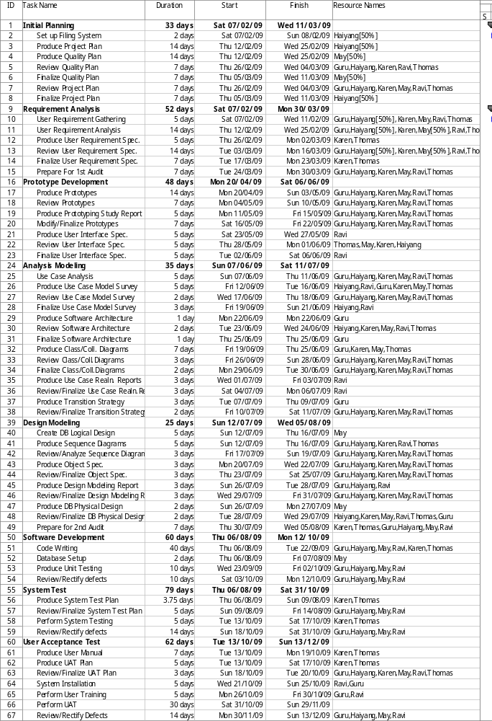
Figure 5.1 Main Activities and Timescale
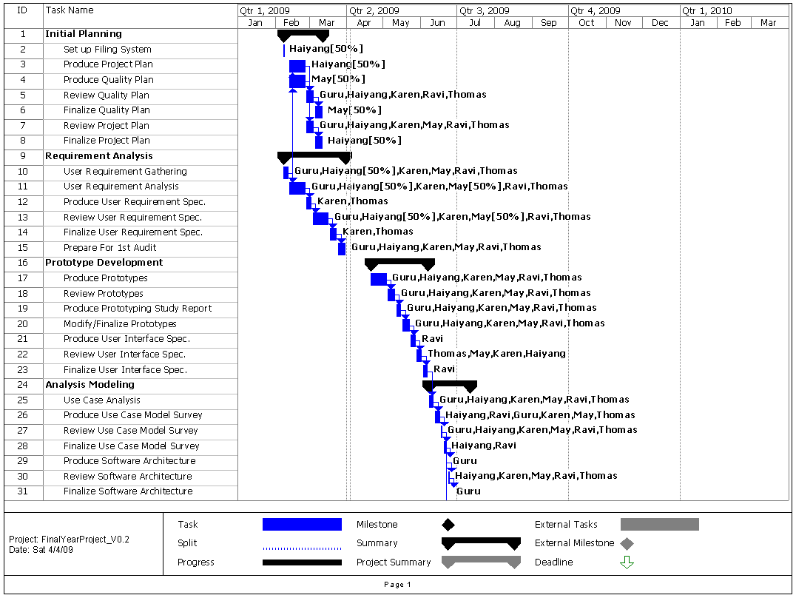
Figure 5.2 Project Gantt Chart - 1

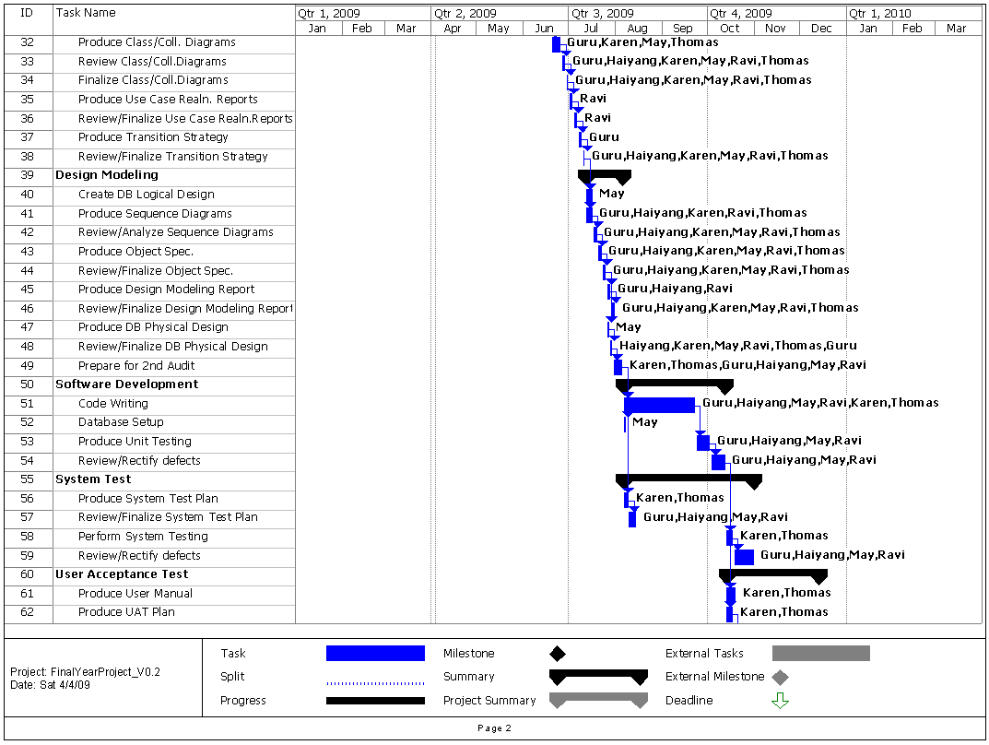
Figure 5.3 Project Gantt Chart - 2
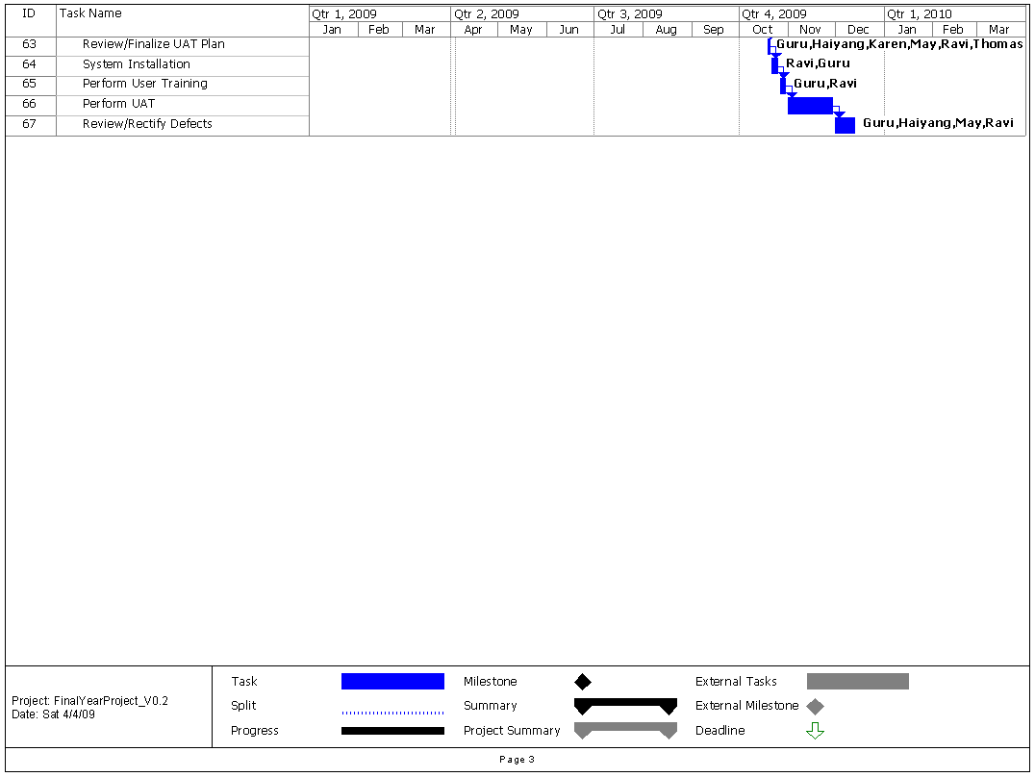
Figure 5.4 Project Gantt Chart - 3

Table 5.2 Project Milestones
Project Milestone |  |  | Approx. Date
ACTIVITY 1: |  | INITIAL PLANNING
1.1 | Finalize Project Plan |  | 04/03/2009
1.2 | Finalize Quality Plan |  | 11/03/2009
ACTIVITY 2: |  | REQUIREMENT ANALYSIS
2.1 | Finalize URS |  | 23/03/2009
ACTIVITY 3: |  | PROTOTYPE DEVELOPMENT
3.1 | Complete System Prototypes |  | 15/05/2009
3.2 | Finalize User Interface Spec. |  | 06/06/2009
ACTIVITY 4: |  | ANALYSIS MODELING
4.1 | Finalize Use Case Model Survey |  | 21/06/2009
4.2 | Finalize Class/Coll. Diagrams |  | 30/06/2009
4.3 | Finalize Use Case Realn. Report |  | 04/07/2009
ACTIVITY 5: |  | DESIGN MODELING
5.1 | Finalize Sequence Diagrams |  | 19/07/2009
5.2 | Finalize Design Modeling Report |  | 31/07/2009
ACTIVITY 6: |  | SOFTWARE DEVELOPMENT
6.1 | Complete coding |  | 22/09/2009
6.2 | Complete bug-fixing and enhancements |  | 12/10/2009
ACTIVITY 7: |  | SYSTEM TEST
7.1 | Finalize System Test Plan |  | 14/08/2009
7.2 | Complete System Test |  | 17/10/2009
ACTIVITY 8 |  | USER ACCEPTANCE TEST
8.1 | Finalize UAT Plan |  | 20/10/2009
8.2 | Complete UAT |  | 29/11/2009
8.3 | Complete Enhancements |  | 13/12/2009
ACTIVITY 9 |  | SIGN OFF
9.1 | Get User Sign Off |  | 13/12/2009

Deliverables
The following deliverables will be produced in the process of project implementation:
- Project Plan.
- QA Plan.
- User Requirement Specification.
- System Specification.
- System Test Plan.
- System Testing Logs (including testing results and debugging logs.)
- UAT Plan
- User's Manual.
- Programmer's Manual.
- Source and Executable Code.
- Progress Reports.

Deliverables
The following deliverables will be produced in the process of project implementation:
- Project Plan.
- QA Plan.
- User Requirement Specification.
- System Specification.
- System Test Plan.
- System Testing Logs (including testing results and debugging logs.)
- UAT Plan
- User's Manual.
- Programmer's Manual.
- Source and Executable Code.
- Progress Reports.

Project structure and staffing
The following staff will be involved in the project:
Below the major responsibilities and deliverables are listed under individual’s name. All the members are expected to be actively involved in the project, so most of the deliverables will be generated through cooperation among all the team members.

Sui Haiyang (Haiyang) – Project Manager
Haiyang will be responsible for managing the project. He will assign tasks, remind deadlines and follow-up on a week to week basis. He will also be reviewing progress against the plan and instituting appropriate action. He will keep Client informed of the major change in the agreed schedule and deviations from the original system design.

Haiyang will communicate to the team any change on the project plan. He will also provide advice to the team on the priority of work.

Gao Jia Si, Karen (Karen) – Quality Manager
Karen will manage all the documentations of the project. She will see to it that all documentations required to carry out this project are complete and are of good quality. She will also verify that each document follows the format provided for by ISS. She will also be responsible in checking that that these documents are phased and submitted according to the deadline.

Karen will be assigned to be the quality manager. Her first task is to define and produce the Quality plan. All the tasks affecting quality in the project has to be coordinated with her.

She will also define the coding standards and Database naming conventions to be used.

She is also in charge of communicating the quality guidelines to each of the leaders of the task. Where and when it is applicable, she will perform audit on each task design, implementation and deliverable.

Yap Sie Kuok, Thomas (Thomas) – Testing Manager
Thomas, will be responsible for the testing of the system. He will design and document all the test plans. He will also create the User Acceptance Test package. He will liaise with the client to get this document approved.

He will also assign testing tasks to all testers. And manage accordingly that all tests are conducted according to the plan, on schedule and of quality.

For succeeding changes and bug list, he must create new test plans for these.

May Ann Sallan (May) – Database Designer
May will take lead in database design. She will have to understand business logic of the system and be able to come up with the DB design needed to support the said business logic. This design will then be presented to the team for thorough discussion and brainstorming.

Once the db design is final, she will create the db scripts to create the database and tables on each of the developer’s machine. This will ensure that all developers are working with the same DB objects and will prevent any conflict that may arise if the developers will create their own databases manually.

Should there be any need for change in any of the DB object by anyone from the developers, these have to be communicated to May first and have to be approved by everyone. Once approved, May will create the DB scripts to update/create the database object.

May will also be the key person to produce the final DB scripts, and DB installation document at the end of the project.

Rajendran Kumaraguru (Guru) – System Architect
Guru will be responsible for the overall system design and framework of this project. Initially, he will have thorough discussion with the Technical Lead, Ravi and will then, present and propose the framework to everyone in the team. Once the framework and design has been finalized, Guru will initiate and produce the System Technical Design Specifications Document.

He may not write the entire TDS, but he will see to it that each contribution of each member on the system design document is in accordance to the agreed framework.

Guru will also create an initial design of the system, and if applicable, will demonstrate to everyone how to set up his/her own development environment.

Thiyagarajan Ravikumar (Ravi) – Technical Lead
Ravi will be responsible in seeing through all the development work. He will provide the prototype of the initial design of the system. And he will appropriately assign the module development and testing to any member of the team.

Ravi will also write the programmer documentation, installation and user training activities. He will also perform the general project administration activities.

It is expected that at the development phase, he will be in close communication with the project Manager, Haiyang.

Project structure and staffing
Following resources will make sure the team members successfully accomplish the tasks assigned.

Accommodation
Team members will finish most of their jobs at home, using laptops. They will gather in ISS for group discussion.

Computer Hardware and Software
During development, the individual’s PC/Laptop will be enough. Desktops installed in ISS can also be used for development.
Following software is required:
- Windows XP Professional
- Microsoft Office 2003
- Microsoft Project 2003
- Microsoft Visio 2003
- IIS
- Visual Studio 2008
- MS SQL Server 2005
- .NET Framework 3.5
- AJAX

Word Processing
Microsoft Word 2003 and Microsoft Excel 2003 will be used for word processing. No other requirements.

Approval Record DOCS/Forms/Approval
Project Name Content Management Portal
Document Ref CMP/DOCS/MP.1/2.0
Approved by Haiyang | Date 04/04/2009
Authorised by | Date
The document authorisation appears on the title page.
The structure of the document is logical.
The distribution list is correct.
The title page is signed
Calculations appear reasonable, are neatly presented and have been checked.
Theory and formulae are correct and properly applied.
Illustrations are relevant, readable and logically placed.
There are no typographical errors.
Units are consistent throughout.
The security classification is correct.
There are no obvious omissions.
The document complies with the Client's requirements, however specified.
Responsibility is accepted for all opinions, conclusions and recommendations.
The document does not run counter to company policy.

